Closing Time – Advanced Booking Form
ROS Member’s Name
Ticketholder’s Name
Address
Ticketholder’s Contact Number
Ticketholder’s E-Mail Address
Performance Date | Fri 26th Apr (Evening – 19:30)  Sat 27th Apr (Matinee – 14:30)  Sat 27th Apr (Evening – 19:30)
Seat Preference
Your data will be collected and processed in accordance with the Reading Operatic Society Members and Supporters Privacy Policy, which is available to view on the Society’s website. The information used on this form will be used for Closing Time Ticket Administration purposes only. You understand that by submitting this form you are consenting to your data being used according to this Policy.
If the ticket holder would like to receive updates from Reading Operatic Society about news and future events, please tick the following box;
E-Mail [ ] (You can opt out from receiving updates at any time)
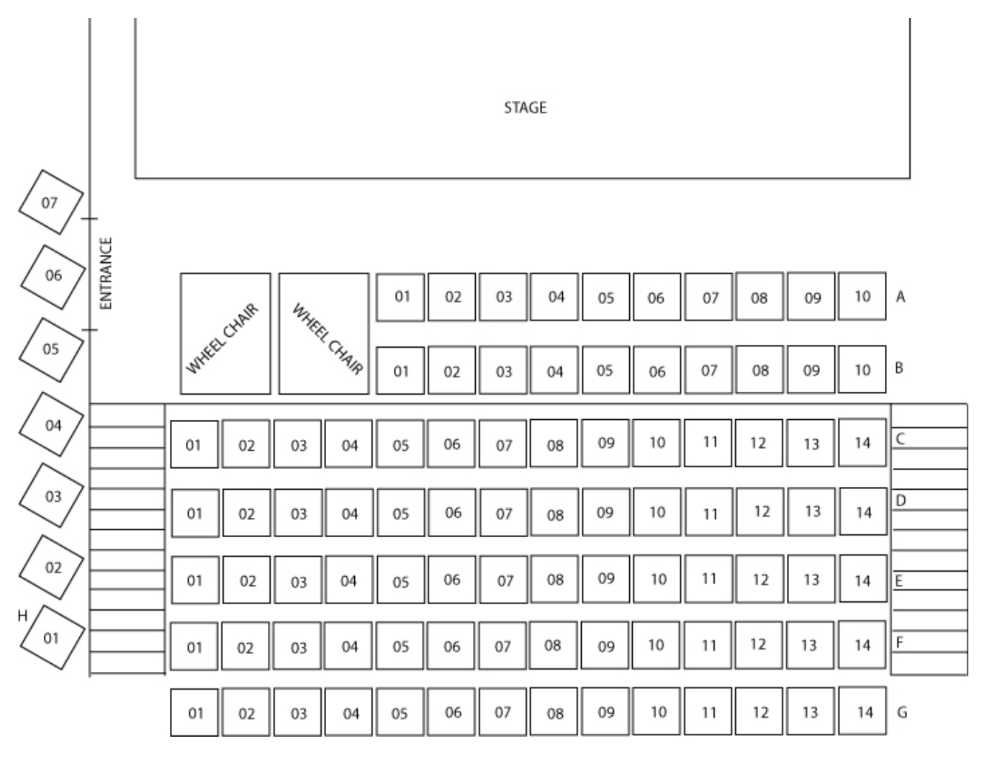
Cheques should be made payable to Reading Operatic Society. You can also pay by BACS, details will be provided on confirmation of ticket availability.
For office use only, please do not complete
Reference Number
Seats Allocated
Payment (Amount / Received)
Date of order

